**Software Engineering Assignment**

**MODULE: 1 (SDLC)**

**Q. What is software? What is software engineering?**

A. The software can be best defined as a set of instructions, technically referred to as programs, that perform operations and specific tasks based on the commands of the user.

Software engineering: Software engineering is a detailed study of engineering to the design, development and maintenance of software

**Q. Explain types of software**

A. There are mainly 5 types of softwares:

1. System softwares: System software allows the user to run computer software or hardware and is responsible for managing their interaction with each other.

i.e. OS, Device drivers, Firmware, Utility, etc.

2. Application softwares: [Application software](https://www.simplilearn.com/tutorials/programming-tutorial/what-is-application-software) or application programs are end-user programs that serve specific functionality to help users accomplish certain tasks

I.e. Database like MYSQL, MongoDB, etc., multimedia, web browsers, freeware like skype, zoom, whatsapp, open-source softwares, etc.

3. Programming softwares: Programs and software are created by coders using different software tools, known as programming software.

i.e. compiler, debugger, linkers, malware

4. Driver software: Audio driver, video driver

5. Middleware: Database middleware, server middleware

**Q. What is SDLC? Explain each phase of SDLC**

A. SDLC stands for software development life cycle.

There are six phases:

1. Requirement – identify client requirements

2. Analysis – Analysis of all requirements

3. Designing – Front-end (HTML, CSS, javaScript, Reactjs, Angularjs)

4. Coding/Development- Back-end (Python, PHP, JAVA, .Net, Node.js

5. Testing – To test the website or software

6. Maintenance-To maintain website/software

To provide updates

**Q. What is DFD? Create a DFD diagram on Flipkart**

A. DFD stands for Data Flow Diagram. It is a way of representing a flow of data through a process or a system. It provides information about the outputs and inputs of each entity & the process itself.

**Flipkart DFD Diagram**

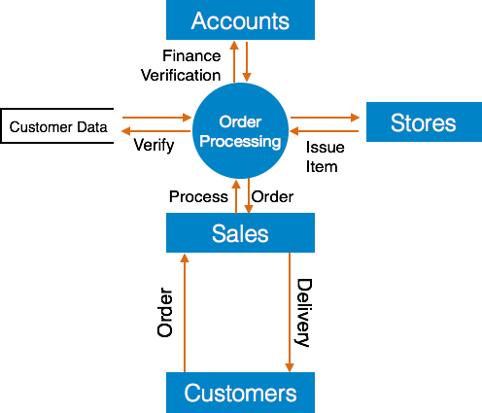

**Q. What is Flow chart? Create a flowchart to make addition of two numbers.**

A. By using flow chart we can understand the flow of code/program.

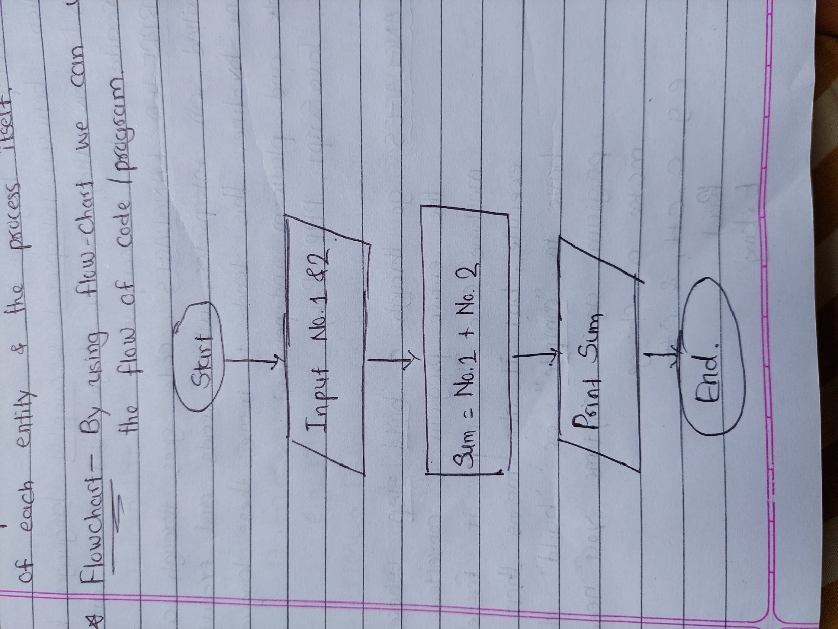

**Q. What is Use case Diagram? Create a use-case on bill payment on Paytm.**

A. Use-case diagrams describe the high-level functions and scope of a system.

Below is the use-case on bill payment on Paytm.

